Integrating computational tools into foreign policy: Introducing Mesa Packages with a coalition algorithm

|  |
| --- |
| Thomas D. Pike |
| Department of  Computational Social Science |
| George Mason University  4400 University Drive  Fairfax, VA, USA |
| tpike3@gmu.edu |

**Acknowledgements:** I would like to thank Rob Axtell, Andrew Crooks, Bill Kennedy, Jackie Kazil and David Masad for their support on this project.

ABSTRACT

This paper conducts an exhibition of the Mesa Packages programming repository as a nascent effort to integrate computational tools into foreign policy. The goal of Mesa Packages is to create a robust ecosystem of social science algorithms so researchers and practitioners can employ these tools to create rigorous and insightful models of complex systems. Through the application of the inaugural algorithm, the Bilateral Shapley Value, a computational model produces agreement with the ongoing Libyan civil conflict and explores different policy choices. The results provide insights into the situation in Libya as well as possible implications for foreign intervention. The underlying algorithm can be implemented in one line of code and can be freely used and improved by researchers and practitioners. As the Bilateral Shapley Value is one approach among many, a rich repository of such algorithms may prove invaluable to foreign policy analysis and implementation.

**Keywords:** Libya, Intervention, Foreign Policy, Analysis, Agent Based Models, Computation.

# Computational tools, mesa packages and an INAUGURAL model

Computational tools have the potential to dramatically aid foreign policy by allowing professionals to invoke advanced theories, test inferences, and try different policy combinations prior to implementation. If developed, repositories of optimized social science coding modules can serve as a technical bridge between practitioners and researchers. Foreign policy professionals can use these modules to create customized models for their specific challenges. These models can allow foreign policy professionals to test their inferences by attempting to simulate what they see in real life. These models can also allow foreign policy practitioners to test competing policy approaches and see their possible impacts. Computational tools have the potential to provide support to foreign policy, but require a supporting ecosystem before they can be widely employed.

Machine learning libraries such as Scikit-learn and deep learning libraries such as Tensor Flow provide a template for rich ecosystems of advanced algorithms. These libraries provide highly optimized code of regularly used statistical algorithms and neural networks, which data practitioners can apply to their unique problem set. Data practitioners do not have to rewrite logistic regression, principal component analysis, k-means clustering, or forward and backward propagation algorithms. Instead, the data practitioners focus on their data and are able to employ various machine learning or deep learning tools with a significantly reduced amount code, through optimized modules. Foreign policy organizations can use the same process to leverage algorithms from the social sciences and apply them to computational models.

“Mesa Packages” is a nascent effort to develop a repository of social science algorithms to aid in policy development (Figure 1). Mesa Packages is based on the Python programming language and the Agent Based Model (ABM) library, Mesa (Kazil & Masad, 2018). Although the choice of language and modelling interface is highly debatable, Python represents a rapidly expanding, comparatively easy to learn object oriented programming language (Sonmez, 2017). Critically, Python has a rich ecosystem which includes highly developed and wide ranging libraries, which foreign policy practitioners can intertwine easily to address the unique complexities of their situation and the available information. As a widely used language employed in everything from YouTube to bioinformatics, Python supports a large toolbox from which practitioners can draw to understand their foreign population and phenomenon of interest. Python provides computational tools to aid in data collection, analysis and geospatial integration. Mesa Packages is then intended to further expand these capabilities by providing a repository of social science based algorithms.

To demonstrate both how foreign policy professionals can employ computational tools and how Mesa Packages can serve as a repository, this article conducts an exhibition of a foreign policy model based on the question “What impact would a major foreign intervention in Libya have on alliance formation?” As the term major foreign intervention is subjective it would include a foreign military presence (e.g. U.S., E.U., Russia) as well as an influx of foreign aid, which would be comparable to at least half of Libya’s Gross Domestic Product. This question is significant because the alliances and relative strength of those alliances will shape the conflict, its outcome, and the future path of Libya. This question is also combinatorically intensive. The model examines 128 tribes and assesses their optimal alliance choices, dynamically. As the tribes form alliances then their preferences and power change causing other tribes to reassess whether or not to attempt an alliance. The core algorithm is a specific instantiation of the Shapley value, the Bilateral Shapley Value (BSV) (Abdollahian, Zinig, & Nelson, 2013; Ketchpel, 1995). This algorithm is from the field of coalition game theory and is based on Nobel prize winner Lloyd Shapley’s work. The Shapley value is a widely applicable and well respected algorithm (Roth, 1988) and as such represents a great candidate for the inaugural algorithm. The algorithm can be employed in any context where individuals or groups may form an alliance from voting to civil conflict.

[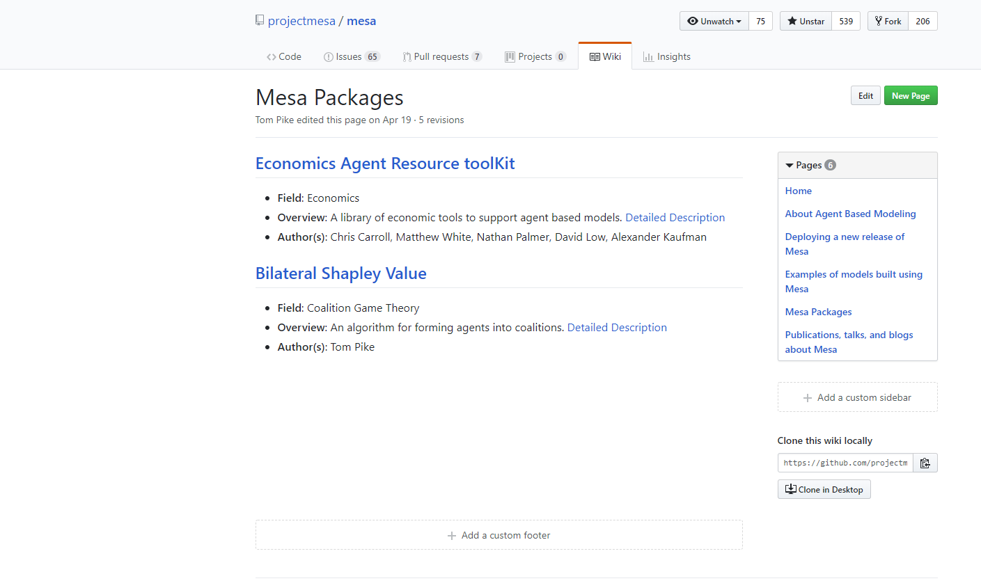](https://github.com/projectmesa/mesa/wiki/Mesa-Packages)[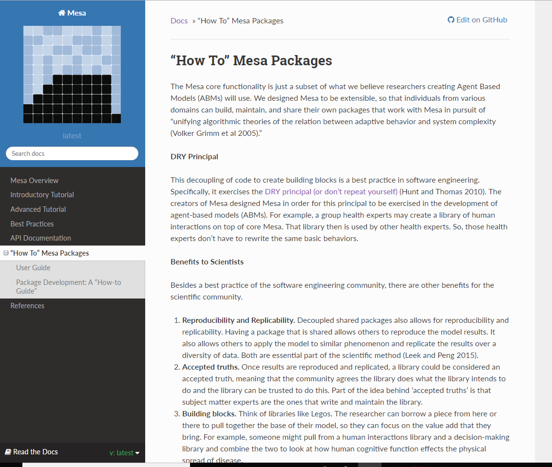](http://mesa.readthedocs.io/en/latest/packages.html)**Figure 1:** (left) Mesa Packages Repository Page <https://github.com/projectmesa/mesa/wiki/Mesa-Packages> (right) Mesa Packages Tutorial Page <http://mesa.readthedocs.io/en/latest/packages.html>

The exhibition of Mesa Packages through the BSV as applied to Libya then proceeds in four parts. First, a background section. This section includes a literature review of computational models and conflict, and an overview of the ongoing conflict in Libya. The next section is the computational model, which applies the BSV algorithm using a qualitative assessment of the preference and power of 128 Libyan tribes. The next section is discussion of the verification of the model, the results of the model, and the validation of the model. The final section is a discussion from two perspectives, (1) the implication of the results from a foreign policy perspective and (2) a discussion of the BSV as the inaugural exhibition of Mesa Packages.

# Background

## Literature review

Computational models are widely used to study conflict. Briefly, there are two types of models regularly used to study conflict, Systems Dynamics and agent-based models (ABMs). First and most predominantly there is system dynamics models which look at systems as an indivisible whole (Gilbert & Troitzsch, 2005). There is a large number of system dynamics models which extend back to as early as the 1970s (Noton, Mitchell, & Janes, 1974) and even the “spaghetti diagram” which was portrayed in popular media as the U.S. strategy in Afghanistan was a systems dynamics model using Stella (Joint and Combined Warfighting School 14-2, 2014). ABMs (also known as multi-agent systems, individual based models or entity based models) encode processes in agents. Agents then use these processes to make decisions based on their specific situation in their environment (Gilbert & Troitzsch, 2005). ABMs are also used for conflict modelling with Joshua Epstein’s “Modelling Civil Violence” as a notable example of a civil conflict ABM (2002).

Typically, models do not try to describe the whole conflict, instead they look at specific aspects, such as the impact of discriminate or indiscriminate targeting (Bennett, 2008; Kress & MacKay, 2014), the impact of climate variability and conflict onset (Zinig & Zagorowski, 2017) or the impact of aid vs. force (Caulkins, Grass, Feichtinger, & Tragler, 2008; Findley & Young, 2007; Pechenkina & Bennett, 2017). Finding the optimal level of resolution for any model is a fundamental problem. If the model is too simple critical mechanisms to understand the phenomenon are ignored, but if it is too complex the analysis becomes too cumbersome (Grimm et al., 2005). This challenge is an essential reason why modelling needs to be accessible to more than just experts. Foreign policy practitioners must able to apply models to the specifics of their problem as there are not enough modelers to work with practitioners to provide specific models for each situation’s unique subtleties. Rich repositories of algorithms can enable this customization for foreign policy practitioners by providing optimized code and a technological bridge to rigorous theories.

The Libya model is coded in Python 3.6 with an ABM construct. I chose an ABM approach for two reasons. First, ABMs are able to look at individuals or in this case the group level. This allows the practitioner to see how different groups may react to different policy choices. This provides greater understanding by showing how entities within the population may react instead of the system as a whole. This knowledge can then enable additional and targeted policy actions. Second, ABMs are more easily scalable. Agents can be individuals in a village or, as in this model, groups within a nation. It is also possible to link ABMs together to have hierarchies within a model where individual dynamics can feed group behavior, which in turn produce a national emergent behavior (e.g. conflict, dictatorship, theocracy). ABMs provide a more flexible framework which is necessary when dealing with large diverse organizations.

It is important to note, although I use an ABM construct for my model, the BSV and coalition game theory does not specifically require ABMs. Coalition game theory is concerned with the combinatorics of coalition formation (Yoav & Leyton-Brown, 2009). The large numbers of groups and their possible alliances and compromises requires computation to explore these combinations efficiently. This model does meet the minimum criteria for an ABM model as self-contained agents interact with other agents. This interaction changes their attributes and viewpoints, which then changes the nature of their future interactions (Gilbert & Troitzsch, 2005). This dynamic produces bottom up phenomenon as local interactions produce the emergent nature of the country. The model however does not have many of the other features seen in typical ABMs such as time steps, although it is possible to add these features. This was done intentionally to create a malleable building block which other models can use through the Mesa Packages repository.

## Background Libyan Civil war

A basic background of Libya’s civil war is necessary to understand the methodology and purpose of this model. The Arab Spring, a series of popular uprisings in Arab countries, began in Tunisia in December 2010 and spread to Libya in February 2011. A popular revolt started against Muammar Gaddafi’s despotic government, which had been in place since 1969. Gaddafi responded by trying to violently suppress the uprising. In March 2011, the United Nations voted for a no-fly zone over Libya to protect civilians. The North Atlantic Treaty Organization executed the no-fly zone tipping the balance of power against Gaddafi’s security apparatuses.

By August 2011 Gaddafi’s rule was effectively over as the General National Congress (GNC) took control of the government from the National Transition Council. On October 20, 2011 Gaddafi was captured and then killed. Libya continued the difficult process of forming a new government, only to erupt in a second phase of civil war beginning in 2014. Elections in June 2014 resulted in a defeat for the Islamist dominated GNC, who refused to step down. The elected House of Representatives (HoR) tried to assume control of the government resulting in conflict between these two groups. In addition, Islamic extremists, such as Al-Qaeda and the Islamic State, had taken or took control of the cities of Sirte, Benghazi and Derna. Through the resulting conflict the HoR fled from Tripoli to Tobruk.

In January 2016, the United Nations tried to broker a peace agreement which produced the Government of National Accord (GNA). The HoR and GNC do not recognize this new government although the international community recognizes it as the official government of Libya. Since 2016 the HoR, allied with General Haftar who commands the Libyan National Army (LNA), made steady progress eastward from Tobruk fighting extremists in Benghazi and Derna as well as securing the major oil revenue pipelines (Figure 2). The LNA is stopped outside of Sirte, and major push into Sirte would signify the beginning of a third phase of conflict between the LNA and the powerful Misratan militias, who seized Sirte from extremists in late 2016.

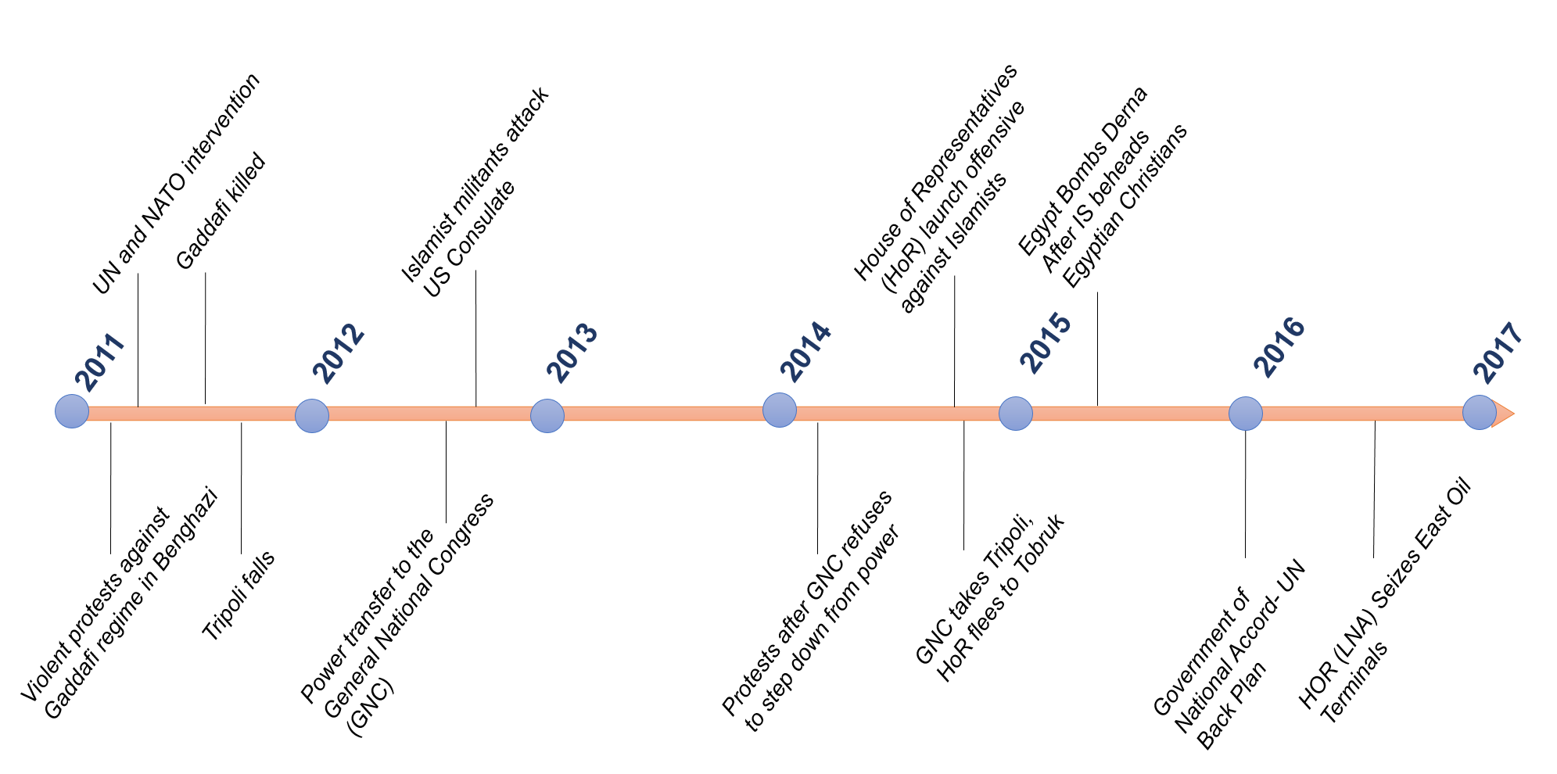

**Figure 2**: Timeline of events in Libya

(Boduszyński, 2015; “Libya profile - Timeline - BBC News,” 2017)

# COmputational model

## Qualitative Assessment of Libyan Groups

The model looks at the Libyan civil conflict from the perspective of how foreign support will influence the decision making of the major tribes as they seek to maximize their situation and shape the emerging order. This approach is consistent with civil wars as highly fluid situations of changing coalitions and local fights, where participants leverage the warring factions for their own ends (Kalyvas 2006).

The challenge is there is little data on how each Libyan perceives the situation, what emergent power structure they may support, and under what conditions they will support different coalitions. As foreign policy assessments must use the best information available and infer many details, this qualitative assessment step represents the heavy-lifting required by foreign policy analysts. Libya has approximately 140 tribes and although Gaddafi tried eliminate the tribes as a part of Libyan identity they still offer a fair representation of the different views of Libyan society (Hatitah and Al-Awsat 2011; Tempelhof and Omar 2012; Masson and Freidel 2012; Eriksson 2016). Based on this information, the tribal level was selected as the appropriate level of analysis.

As there is no recent comprehensive study of Libyan tribes, I developed a list of 128 groups through a variety of studies. Several studies described local tribes and their dynamics during the civil war. These studies did allow for a qualitative assessment for several tribes in each of the major regions of Libya (Lacher 2011; Fitzgerald 2015; Eriksson 2016; Boduszyński 2015; Cole and Mangan 2016; Cole and McQuinn 2015). A challenge arose when these tribal groups and their estimated size were compared with population estimates of Libya. There are several areas, particularly in the more densely populated west, for which there was not detailed information. To account for these populations I made inferences based on geographic alignment and historic coalitions. I also accounted for groups of people who are not affiliated with any major tribe and which are aligned with various ideologies in urban centers. This process gave me a list of 128 groups.

Throughout the process of identifying the major groups, it was also necessary to determine two attributes for the BSV algorithm, preference and power. For preference, this was the group’s ideological affinity. This was assessed using the ubiquitous one dimensional political spectrum prevalent throughout modern politics and dating back to the French revolution (Ferris, 2011). Ideological affinity was assessed on a 100 point scale ranging from 0.0 to 10.0. A value of 0.0 represents an ultra-nationalist who is secular and is concerned for the stability of Libya even if another dictator is in charge. A value of 10.0 represents an Islamic extremist, such as those embodied by the Islamic State ideology. Based on the historical background there were three points on this spectrum which are representative of the various competing ideologies. First, an affinity score near 3.0 represents nationalists. Groups who had more secular leanings and generally looked to historical precedent to shape their views of Libya’s future. Second, 6.0 represents fundamentalists. Groups who wanted a more religious society were closer to 6.0, with more fundamentalist groups that followed Salafist traditions (Islamic tradition most closely associated with Saudi Arabia) had higher scores closer to 7 or 8. Islamic extremists, most closely associated with zealots such as Al-Qaeda or the Islamic State had scores at 9 and above.

The average of two other variables, economic resources and military capability, was used to assess a group’s power. The two variables were selected based on research of political survival and civil war. Groups need economic resources to distribute public and private goods (Bueno De Mesquita, Smith, Siverson, & Morrow, 2003) and need a monopoly of force to maintain their power (Weber & Dreijmanis, 2008). Economic resources were based on a group’s geographic location and assessed access to major revenue sources also on 100 point scale from 0.0 to 10.0. Qaddafi had a large government which by some estimates employed up to 80% of the population (Elgazzar et al. 2015). Post-Qaddafi Libya has two major revenues sources, trade between Europe and Africa (much of it illicit) and oil (Shaw and Mangan 2014; U.S. Energy Information Administration 2016). An assessment of the group’s access to trade revenue and oil revenue accounting for damaged infrastructure as of spring 2017 formed each group’s economic resources value.

For military capability, I was unable to find detailed descriptions of different militia organizations, military hardware (tanks, planes, etc.) and leadership (ability to leverage these resources and command a following) which would be used for a traditional military assessment. Therefore, each group’s military capability value was assessed based on demonstrated capability and known foreign support. For example, Egypt provided air support to LNA actions against extremists in Derna and generally appears to provide minor military support to the LNA (“Egypt Launches Strikes in Libya after Minya Attack | Egypt News | Al Jazeera” 2017; “Khalifa Haftar Forces Capture Key Libya Oil Terminals | Libya News | Al Jazeera” 2017). Military capability was also assessed on a similar 100 point scale.

A complete listing of all tribes, their affinity, military capability and economic resources values are located on my GitHub page at <https://github.com/tpike3/Libya-CoalitionFormation>. Due to the challenges of data these assessments can be subject to intense discussion. This then becomes the critical point, analysts regularly must make such assessments in data sparse environments. These assessments are an immense challenge and the focus of much analytic effort. Computational tools can then help analysts test and explore their assessments supported by rigorous theories.

## The Libya Model

The computational model has five steps: (1) Agent Instantiation, (2) Coalition Formation, (3) New Agent Formation, (4) Check Coalition, (5) Output (Figure 3).

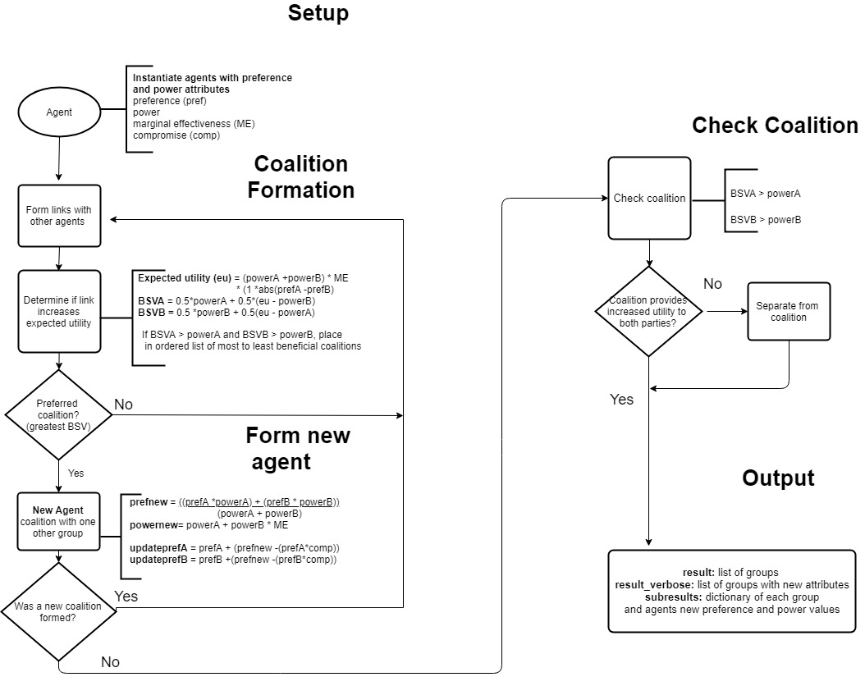

**Figure 3**: Flow Diagram of Computational Model

### Agent Instantiation

The first step reads each group from a data file and instantiates them as an agent object with the preference and power attributes. Each affinity value is normalized over the range of inputs and stored as the agents original preference value. The military capability and economic resource value are normalized over the range of inputs and then averaged together to form the power value.

### Coalition Formation

Step two of the model is to form coalitions. To do this, each pair of agents (A, B) has an expected utility for forming an alliance. The expected utility is calculated:

(1)

Where ε is the marginal effectiveness parameter and v(AB) is the expected utility of the relationship (Abdollahian, Zinig, and Nelson 2013). The expected utility is then used to calculate the BSV of the agent:

) (2)

Where BSV(A) is the bilateral Shapley value for agent A. If the BSV for both agents is higher than their own power value then the BSV is stored as a potential coalition. After all potential coalitions are assessed then each agent is paired with the best possible coalition and a new agent is formed (Ketchpel 1995).

### New Agent Formation

Step three forms a new agent based on the pairwise coalition formation. This requires calculating the new agents power and preference attributes. The new agent preference is calculated:

(3)

Where C is the new agent which has formed. Joining a coalition influences the preference value of its component parts based on the compromise parameter. The preference of the agents component agents is updated by:

(4)

Where γ is the inputted compromise parameter determining how much of an affect the new coalition has the group’s affinity values . The new power of this group is:

(5)

Where C represents the new agent’s power and ε represents the marginal effectiveness parameter. After the new agents form, steps two and three repeat themselves until no new coalitions are formed.

### Check Coalition

In step four each group in the coalition assesses whether they should remain based on the coalition agent’s changing preference and power values as it formed coalitions with more agents. Each agent in the coalition and the coalition as an agent computes (1) their expected utility and (2) their respective BSV. If the BSV for the group is higher in the coalition than without it then the group remains. Otherwise, the group removes itself from the coalition and two new agents are formed. The coalition without the group and the group as an agent. The preference and power of the coalition agent is recalculated using equations (3) and (5), while the power of the departing agent reverts to the original input. The preference of the departing agent is not recalculated as civil conflict has shown that impact on ideologies continues to remain even after the conflict has concluded (Malamud-Goti, 1996).

### Output

After this final step the model then saves a data file with all the coalition agents, their power and preference values as well as the agents within these coalitions with their updated preference and values. The code, plus results are also available on my GitHub page provided in section 3.1.

# Model verification and results

## Verification

To ensure the model was running as programmed I performed two verification procedures. First, I tested each function as it was being built to ensure it behaved as expected and did not produce any errors. Second, I inputted extreme parameters to see if they produced the expected results. This included inputting a marginal effectiveness parameter of 1.0 and below. As expected, no agent formed a coalition with any other agent since there was no benefit. Similarly, I inputted a marginal effectiveness parameter above 2.0. The expected result from these inputs were the formation of a grand coalition which contained all agents (Yoav & Leyton-Brown, 2009) and this result was produced. I also tested the compromise parameter. If the compromise parameter was 1.0, the agents should all adopt the preference of the coalition agent and no agent should defect from the coalition. In addition, if the compromise parameter is 0.0 then no agent should alter their preference and there would be defections. For both values the expected results occurred. To test the robustness of these verification results I also conducted these tests using generic data over uniform and power law distributions. In each case the expected result was produced.

## Results

The model was run for 450 iterations which consisted of 150 runs over varying parameters for three different foreign policy options, (1) no support or intervention, (2) massive support to one nationalist group, (3) support to three groups, nationalist, nationalist-fundamentalist, and fundamentalist. Each of these three policy options was run over a range of parameter inputs, with greater focus on ranges which produced realistic results.

### Impact of Parameter Variation

As noted in section three, the model has two parameters the compromise parameter and the marginal effectiveness parameter. The compromise parameter determines how far agents will alter their preferences when they join a coalition. The model was run with 10 values ranging from 0.1 to 1.0. A compromise parameter of 0.1 means groups will alter their preference only slightly when joining an alliance, while a 1.0 compromise parameter means they will alter their preferences to that of the coalition. This approach increases complexity as the model now has agents existing multiple levels, coalition agents interacting with each other and individual agents interacting within the coalition. The marginal effectiveness parameter consisted of 15 values ranging 1.1 to 3.0. The marginal effectiveness parameter determines how much additional benefit each coalition gets by working together.

The marginal effectiveness parameter had the most impact over a small range. A marginal effectiveness parameter from 1.1 to 1.6 with any compromise parameter above 0.4 produced a significant increase in coalition formation. A low compromise parameter of less than 0.3 combined with a marginal effectiveness parameter between 1.1 and 1.4 shows the greatest variability both in different numbers of agent formations. The marginal effectiveness parameters of 1.2, 1.3, and 1.4 and compromise parameter of 0.1, 0.2, and 0.3 showed the most variation in the results. Figure 4 shows the results of the three policy choices over all parameter runs. As indicated in the upper left quadrant, a marginal effectiveness parameter between 1.2 and 1.4 and a compromise parameter from 0.1 to 0.3 produced results which were most consistent with observations of Libyan alliances.

Parameter inputs of 1.1 for marginal effectiveness and 0.1 to 0.3 showed the highest spread of groups with roughly three fringe groups who are non-allied groups on the extreme (preference > 9.0 or < 1.0) and then two to four medium sized groups spread across the rest of the spectrum. A marginal effectiveness setting of 1.2 and a compromise setting of 0.2 would result in seven fringe groups and three large groups, with a moderate affinity (0.56) as the largest (48) and most powerful (108.84). Increasing the compromise parameter to 0.3 reduced the fringe groups. The reduction of fringe groups by increasing the compromise parameter also occurred with an increase in the marginal effectiveness parameter, indicating the effect of the compromise parameter was to bring fringe groups into larger coalition formations.

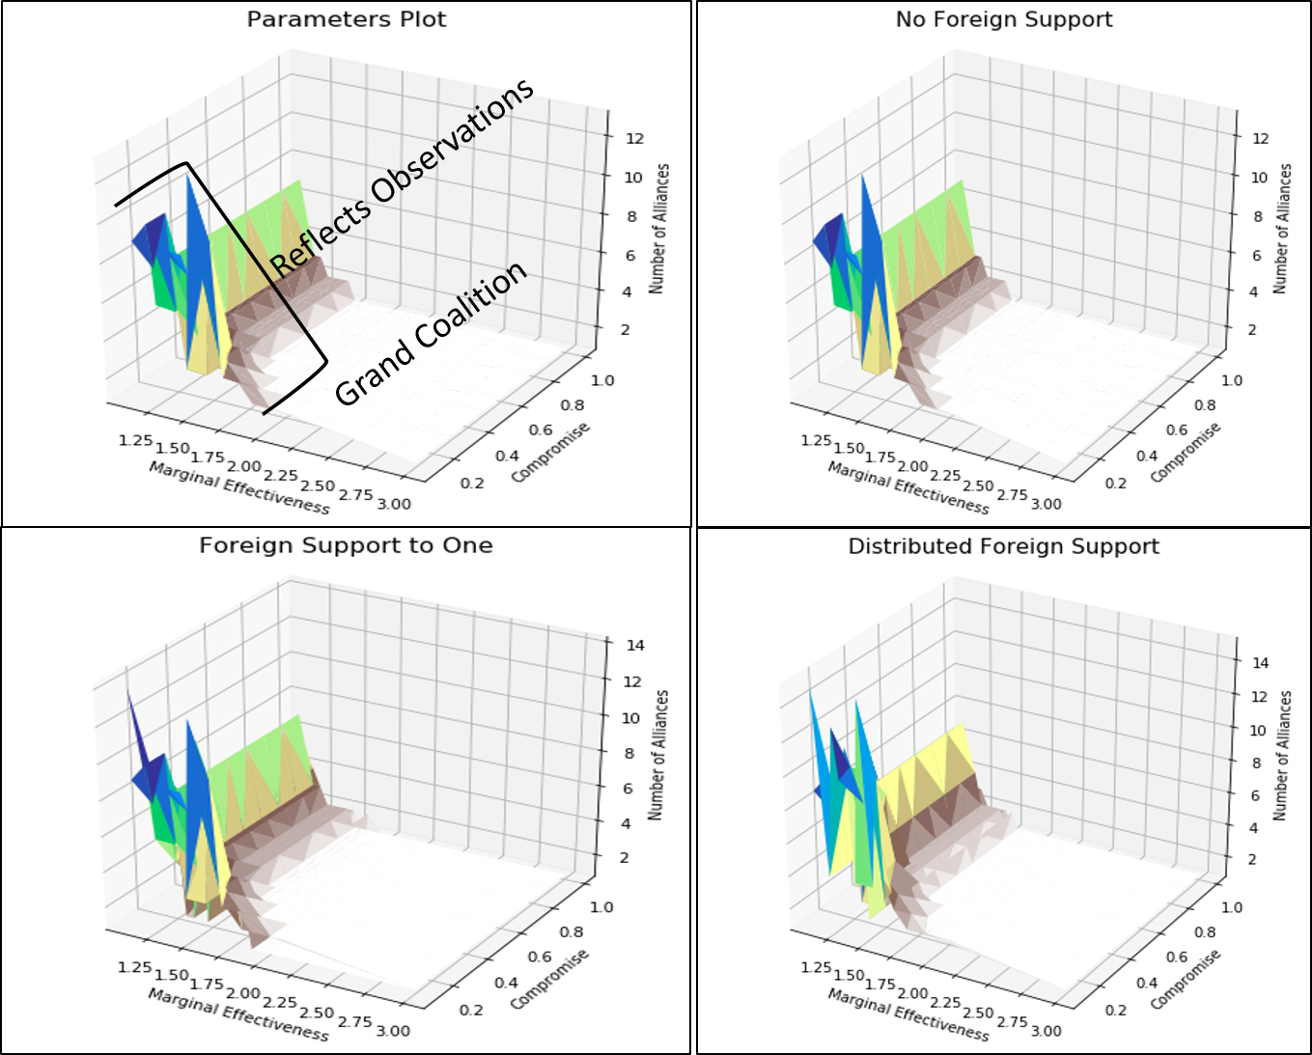

**Figure 4**: Plots of parameter impact on coalition formation (upper left) general description of results using no foreign support (upper right) coalition formation with no foreign support (bottom left) coalition formation with support to one group (bottom right) coalition formation with foreign support distributed to three groups. Color was used to show relief in plot, but has no additional significance.

Parameter variation also impacted the preference of the coalition majority. The increase of the marginal effectiveness parameter results in a majority of fundamentalists or nationalists depending on the parameter. At a 1.3 marginal effectiveness parameter, the fundamentalists have the majority and at a 1.4 marginal effectiveness parameter the nationalists have a majority. Based on these results additional runs at value of 1.35 and 1.45 where conducted. The nationalist only obtained a majority at 1.4 losing it again at 1.45. By 1.5, a near grand coalition was reached where the ideology was centrist at a 0.56 preference and all but the fringe groups were part of the coalition (as shown in Figure 5). Runs at 1.25 and runs at 1.55 showed no significant change. These results are all under conditions of no new foreign support.

### No Foreign Support Results

A marginal effectiveness parameter of 1.3 and a compromise parameter of 0.1 arguably reflects the general situation of Libya (Figure 5 - upper left). A smaller nationalist coalition in the East and larger more fundamentalist coalition in the West with ultra-nationalist and religious extremist groups. Critically, minor variations in the marginal effectiveness parameter can change the balance of power from fundamentalist to moderate, with differing minorities. As will be discussed later in the Validation section, the tribes which make up these alliances do replicate known alliances within existing Libyan coalitions.

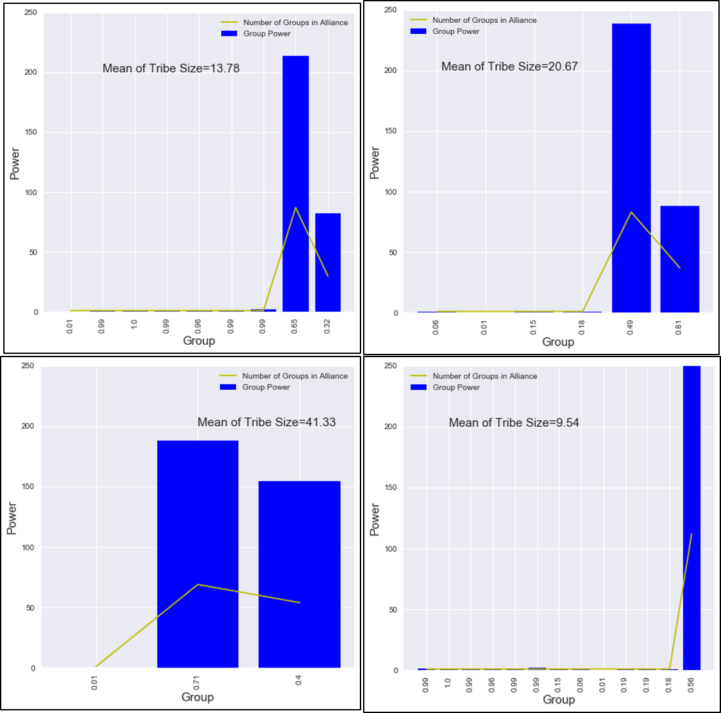

**Figure 5**: Impact on the majority agent preference (ideology) with a compromise parameter of 0.1 and varying marginal effectiveness parameters. (top left) Marginal effectiveness of 1.3, more fundamentalist majority - 0.65 preference. (top right) Marginal effectiveness of 1.4, more moderate majority - 0.49 preference. (bottom left) Marginal effectiveness of 1.45, more fundamentalist majority - 0.71 preference. (bottom right) Marginal effectiveness of 1.5, moderate majority, near grand coalition - 0.56 preference. Mean of tribe size is the average number of groups within the coalitions.

### Impact of Foreign Support

To simulate possible impacts of foreign support a substantial increase of power was provided to one group and then three groups. U.S. support to Afghanistan served as a rough metric of substantial foreign aid. According to the world bank the Afghanistan GDP in 2011 (the peak of U.S. support) was 17.93 billion dollars. U.S. foreign aid provided was 13 billion dollars (USAID, 2018). This does not include military support which is harder to measure quantitatively, but in Libya foreign military support fundamentally shifted the balance of power, whether in the operations which defeated Gaddafi or in providing support to defeat extremists in Sirte. Based on this rough metric, substantial aid represents nearly the entire economic power of the country and military power represents an unmatched capability being provided to various coalitions. To replicate this overwhelming advantage, foreign support was simulated as 99.0 for economic and military power.

For the support to one group, Al-Ubaidat, the most powerful nationalist group received an economic and military boost to 99.0. The results of this policy focus on the parameters which appear closest to the Libyan situation with no foreign support, a compromise parameter of 0.1 and a marginal effectiveness parameter of 1.3, 1.4 and 1.5. Similar to the no foreign support results, the results with foreign support were highly sensitive to the parameters. In each case foreign support was not able to create a nationalist majority. The best result was under a marginal effectiveness of 1.3 where the nationalist alliance increased from 32 tribes to 49 and became slightly more moderate (Figure 6 - upper right). This impact, however, nearly reversed with a marginal effectiveness of 1.4. The results replicated no foreign support parameters of compromise at 0.1 and marginal effectiveness at 1.3 (Figure 5 – upper left), but the nationalist minority was reduced from 37 to 29 and much less powerful, while the fundamentalist majority increased from 83 tribes to 90, and gained a lot of power (Figure 6 - upper right). Increasing the marginal effectiveness to 1.5, resulted in two alliances of the same size (Figure 6 – bottom left). Providing substantial support to one nationalist group did not create a moderate majority, but instead created a powerful minority or an equally sized powerful coalition.

Trying to mitigate a powerful nationalist minority the model then simulated support to a nationalist minority as well as two moderate tribes (Sadat and Awlad Sulaiman), dividing 99.0 military and economic support equally among all three. The result mainly mirrored the results of no foreign support except the near grand coalition occurred at 1.45, while two major coalitions occurred at 1.5 (Figure 6 - bottom right, Figure 5 bottom left). Supporting multiple groups effectively caused the same results as no support, except it made the various coalitions more powerful.

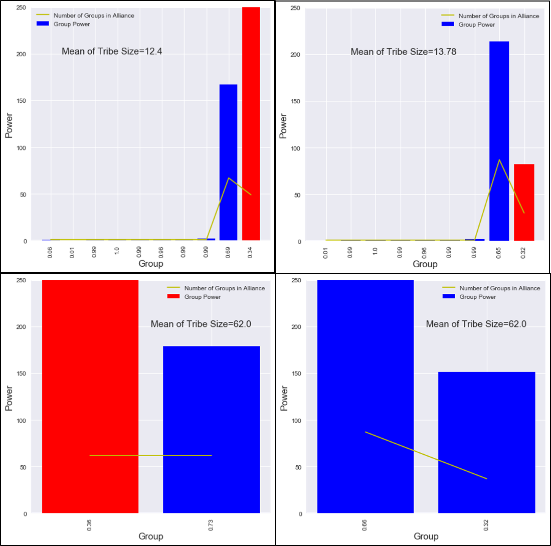

**Figure 6:** Impact of a foreign support (upper left) Major support (al-Ubaidat- red coalition) to one group with a 0.1 compromise parameter and a 1.3 marginal effectiveness. (upper right) Major support to one group (al-Ubaidat- red coalition) with a compromise parameter of 0.1 and a marginal effectiveness of 1.4. (bottom left) Major support to one group (al-Ubaidat- red coalition) with a compromise parameter of 0.1 and a marginal effectiveness of 1.5. (bottom right) Major support to three groups with a compromise parameter of 0.1 and a marginal effectiveness of 1.5. Mean of tribe size is the average number of groups within the coalitions.

## Validation

The specifics of the Libyan coalitions produced by the model show simplistic agreement with known Libyan coalitions. In Tobruk, Sa’ada tribes (which includes the al-Ubaidat) have an coalition with the Murabitin tribes (which includes Qunashat, Habun, Qutan and Mnaffa). These coalitions are replicated in the model as these groups align under the discussed input parameters. The reason the model shows simplistic agreement is because in reality the coalition is tense and requires very complex mechanisms to maintain the coalition which the model is unable to replicate (Kane 2015).

In Sabha, the model shows coalitions with Awlad Sulaiman and Masrata tribes. The Tuareq who are active in the trading networks ally with the more moderate majority, which is consistent with their role as an ethnic minority, who will opportunistically ally to serve their own purposes (Cole and Mangan 2016).

The story for Bani Walid is more complex. The town is made up of five Warfalla sub-tribes (Sa’dat, Jmamla, Sabayi and 2 Mtarfa tribes). Internally, the Mtarfa feel like an oppressed minority who tried to take control of Bani Walid by aligning with Islamists after Gaddafi’s fall. Bani Walid as a city, however, was punished by Gaddafi for decades as it was seen as the origin of a failed coup in the 1990s. This made the dominate three tribes unwilling to rebel in 2011 and they have tried to keep their city out of the civil conflict after retaking the town from the Mtarfa and their more fundamentalist allies (Cole and Mangan 2016; Cole 2015). The model cannot capture these complex dynamics but it does show the Mtarfa aligning with the more extreme fundamentalists coalitions while the Sa’dat, Jmala, and Sabayi align with more moderate nationalist or fundamentalist configurations.

In addition, the model is able to produce extremists groups who do not ally with each other or Islamist groups. This is consistent with the dynamics of the Libyan conflict with extremists and fundamentalists fighting.

Although the model cannot replicate the complex mechanisms of tribal arbitration and rich local histories, it does replicate agreement with known coalitions in Libya.

# Discussion

## Implications for Libya Policy

The impact of foreign aid to one major group (al-Ubaidat) stylistically agrees with macro-level experiences in Afghanistan, where financial and military aid to a specific group makes them more powerful, but can decrease the number of groups with whom they are incentivized ally while increasing the number of groups in an adversarial coalition (Kilcullen 2010). This model shows such a policy may be counterproductive by making a minority coalition against whom a majority coalition forms.

The model also demonstrates the most effective policy may not be increasing a group’s power, but instead increasing their marginal effectiveness. This recommendation agrees with the civil conflict literature (Galula, 2006; Kalyvas, 2006; Kilcullen, 2010), but presents challenges for practical implementation.

## Potential as Tool for Foreign Policy

This model allows a detailed exploration of the numerous groups whose emerging interdependencies will shape the future of Libya. By examining how 128 different groups may react to a large influx of outside support this model assumed a fundamentally different perspective in which foreign actions influence the inner workings, decisions and evolution of the foreign population. Computing the optimal coalitions of 128 groups all examining every other possibility as each new coalition changes their preference and power is a non-trivial task which is made efficient through the aid of computation. As this model can take different numbers of groups, from any population, in any time period, the model offers much greater flexibility in analyzing the formation of coalitions and what aspects of the various groups affected those coalitions. This approach offers significant new possibilities in which to explore the dynamics of foreign populations.

Not only can the BSV algorithm aid understanding, as discussed in section 1, it can be implemented easily and is available through the Mesa Packages repository[1]. With this module, any analyst can quickly incorporate it (assuming a basic knowledge of python). This allows the analyst to focus on the challenge of understanding what is happening in a foreign population and not on the intricacies of coding. If other algorithms from social science were also readily accessible then analysts could combine them to create richer models able to explore a wider variety of phenomenon. For example, the use of the BSV and conflict onset theory were combined to explore the impact of climate variability and civil conflict (Zinig & Zagorowski, 2017). This use makes it similar to parametric machine learning algorithms in wide spread use today, but with the added advantage of being able to take in qualitative as well as quantitative assessments.

## Future Research

### BSV Algorithm

Diversifying the marginal effectiveness parameter so coalitions of different groups produces a different marginal effectiveness value would be a powerful way to extend this model. For example, a Misrata tribe may form a coalition with an Awlad Sulaiman tribe in Sabha to create a trade route to move goods from Europe into Africa and vice versa. This coalition would have greater marginal effectiveness than the Misrata tribe forming an coalition with a tribe from Al-Khums another coastal city. This approach also provides the possibility of seeing what impact improving a specific group’s attributes to alter their coalition benefit may have on coalition formation. This may result in more specific foreign aid policies which have the ability to grow bottom up solutions instead of broad top down foreign policy interventions. What makes the Mesa Packages approach significant is the code is available through GitHub and can be enhanced in any number of directions to include those suggested here.

### Mesa Packages

Expanding Mesa Packages to include a wide range of social science algorithms is the more promising area of future research. In fact a broader and more robust toolkit, the Economic Agent Resource toolkit (ARK) leverages Mesa for economic algorithms and is also connected in the repository (Carroll, White, Palmer, Low, & Kaufman, 2018). Continuing to expand this repository will give researchers and practitioners a rich ecosystem which will allow for greater exploration of complex phenomenon. The world of machine learning and artificial neural networks has already shown the power of such an approach.

# Conclusion

The application of a computational model to Libya’s ongoing civil conflict has demonstrated the potential of such tools to aid foreign policy analysis. This model produced results consistent with observed phenomenon in the conflict, as well as results consistent with other foreign interventions.

The model was able to go beyond human cognitive capability by analyzing the potential combinations of 128 groups. The underlying algorithm, the Bilateral Shapley Value, was also optimized to be implemented in one line of code. This dynamic can allow for wide application to any number of situations from village level arguments, to treaty negotiations, to legislative wrangling to major foreign interventions.

The development of a rich ecosystem of social science algorithms which can be easily employed by researchers, analysts or any other interested individuals has the potential to revolutionize how we understand and engage the world. Creating a robust ecosystem which can be combined in novel ways to explore complex phenomenon has the potential to cause a paradigm shift in how science is conducted and find unifying algorithmic theories for complex adaptive systems (Grimm et al., 2005).

# references

Abdollahian, M., Zinig, Y., & Nelson, H. (2013). Techno-Social Energy Infrastructure Siting : Sustainable Energy Modeling Programming ( SEMPro ). *Journal of Artifical Socieities and Simulation*, *16*(3), 1–12.

Bennett, D. S. (2008). Governments, Civilians, and the Evolution of Insurgency: Modeling the Early Dynamics of Insurgencies. *Journal of Artificial Societies and Social Simulation*, *11*(4).

Boduszyński, M. P. (2015). The Libyan revolution and its aftermath / The 2011 Libyan uprisings and the struggle for the post-Qadhafi future. *The Journal of North African Studies*, *20*(5), 898–900. https://doi.org/10.1080/13629387.2015.1075307

Bueno De Mesquita, B., Smith, A., Siverson, R. M., & Morrow, J. D. (2003). *The Logic of Political Survival*. Cambridge, Massachusetts: The MIT Press.

Carroll, C., White, M., Palmer, N., Low, D., & Kaufman, A. (2018). Heterogeneous Agents Resources and toolKit (HARK). Retrieved June 7, 2018, from https://github.com/econ-ark/HARK

Caulkins, J. P., Grass, D., Feichtinger, G., & Tragler, G. (2008). Optimizing counter-terror operations: Should one fight fire with “fire” or “water”? *Computers and Operations Research*, *35*(6), 1874–1885. https://doi.org/10.1016/j.cor.2006.09.017

Epstein, J. M. (2002). Modeling civil violence: An agent-based computational approach. *Proceedings of the National Academy of Sciences*, *99*(Supplement 3), 7243–7250. https://doi.org/10.1073/pnas.092080199

Ferris, T. (2011). *The Science of Liberty: Democracy, Reasons and the Laws of Nature*. New York: Harper Perennial.

Findley, M. G., & Young, J. K. (2007). Fighting Fire with Fire? How (Not) to Neutralize an Insurgency. *Civil Wars*, *9*(4), 378–401. https://doi.org/10.1080/13698240701699482

Galula, D. (2006). *Counterinsurgency Warfare: Theory and Practice* (2nd ed.). Westport, Connecticut: Praeger Security International. https://doi.org/0-275-99269-1

Gilbert, N., & Troitzsch, K. G. (2005). *Simulation for the Social Scientist* (2nd, Kindl ed.). New York: Open University Press.

Grimm, V., Revilla, E., Berger, U., Jeltsch, F., Mooij, W. M., Railsback, S. F., … DeAngelis, D. L. (2005). Pattern-Oriented Modeling of Agent-Based Complex Systems: Lessons from Ecology. *Science*, *310*(5750), 987–991. https://doi.org/10.1126/science.1116681

Joint and Combined Warfighting School 14-2. (2014). Stability Operations. Norfolk, Virginia.

Kalyvas, S. N. (2006). *The Logic of Violence in Civil War*. New York: Cambridge University Press.

Kazil, J., & Masad, D. (2018). Mesa: Agent-based modeling in Python 3+ — Mesa .1 documentation. Retrieved May 22, 2018, from https://mesa.readthedocs.io/en/master/

Ketchpel, S. (1995). Coalition Formation Among Autonomous Agents. *From Reaction to Cognition*, (957), 73–88.

Kilcullen, D. (2010). *Counterinsurgency*. Oxford: Oxford University Press.

Kress, M., & MacKay, N. J. (2014). Bits Or Shots In Combat? The Generalized Deitchman Model of Guerrilla Warfare. *Operations Research Letters*, *42*(1), 102–108. https://doi.org/10.1016/j.orl.2013.08.004

Libya profile - Timeline - BBC News. (2017). Retrieved May 8, 2017, from http://www.bbc.com/news/world-africa-13755445

Malamud-Goti, J. (1996). *Game Without End: State Terror and the Politics of Justice*. Norman, Oklahoma: Oklahoma University Press.

Noton, M., Mitchell, C. R., & Janes, F. R. (1974). The systems analysis of conflict. *Futures*, *6*(2), 114–132. https://doi.org/10.1016/0016-3287(74)90018-4

Pechenkina, A. O., & Bennett, D. S. (2017). Violent and Non-Violent Strategies of Counterinsurgency Two Broad Approaches to Counterinsurgency. *The Journal of Artifical Societies and Social Simulations*, *20*(4).

Roth, A. E. (1988). *The Shapley Value*. *Game Theory and Applications*. https://doi.org/10.1017/CBO9780511528446

Sonmez, J. (2017). Best Programming Language to Learn: The Top 10 Programming Languages To Learn In 2018. Retrieved May 22, 2018, from https://simpleprogrammer.com/top-10-programming-languages-learn-2018-javascript-c-python/

USAID. (2018). U.S. Foreign Aid by Country. Retrieved June 7, 2018, from https://explorer.usaid.gov/cd/AFG

Weber, M., & Dreijmanis, J. (2008). *Max Weber’s Complete Writings on Academic and Political Vocations*. New York: Algora Publishing.

Yoav, S., & Leyton-Brown, K. (2009). *Multiagent Systems: Algorithmic, Game-Theoretic, and Logical Foundations* (Kindle). New York: Cambridge University Press.

Zinig, Y., & Zagorowski, P. (2017). Climate Variability, Opposition Group Formation and Conflict Onset. In V. G. Duffy (Ed.), *Advances in Applied Digital Human Modeling and Simulation: Proceedings of the AHFE 2016 International Conference on Digital Human Modeling and Simulation* (pp. 183–191). Springer.

1. A detailed description of the module and an example implementation is available at <https://github.com/tpike3/bilateralshapley/blob/master/README.md>